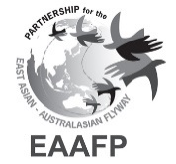
TWELFTH MEETING OF PARTNERS OF THE EAST ASIAN – AUSTRALASIAN FLYWAY PARTNERSHIP
Cebu City, Philippines, 8-14 November 2025

Draft Decision 10 Rev 1
Coordination of Colour Marking of Migratory Waterbirds in
the East Asian – Australasian Flyway Partnership
Submitted by the Technical Sub-Committee and the EAAFP Shorebird Working Group
Summary

Studies of marked migratory waterbirds provide information about movements and life history vital rates that are essential for conservation management. Coordination of marking schemes, required to ensure the integrity of individual projects, has been recognised since the founding of the EAAFP, initially being included as Outcome 10 of the Implementation Strategy for the East Asian – Australasian Flyway Partnership: 2007-2011. Coordination of marking schemes has variously been undertaken by taxonomic Working Groups and Task Forces, and the Secretariat. The comprehensive review of shorebird colour-marking recently completed by the Shorebird Working Group shows what can be done. Currently, there is no agreed structure for coordination of colour-marking within the Partnership and no entity has been identified as being responsible for such coordination.

Background
- Marking of migratory waterbirds using individually numbered metal rings/bands has taken place on the EAAF for more than 100 years. Information obtained was largely restricted to the recovery of dead birds, with only a small number being re-trapped alive or observed such that the ring/band could be read.

- Marking of cranes, swans and geese with individually numbered, readable bands and neck collars started in the EAAF in the 1980s. Marking of seabirds with readable bands (e.g. gannets, terns) has been undertaken for several decades.

- Marking migratory shorebirds with leg flags started in 1990, with plain coloured flags being used to indicate the geographical area where the bird had been marked. Re-sightings of marked birds increased greatly and soon flagging was being conducted at a number of sites along the flyway, requiring a robust protocol to coordinate activities – in recent years many of the flags are engraved allowing individual recognition.

- A temporary Colour Marking Task Force was established by MOP4 in 2010 and subsequently disbanded at MOP7 in 2013, following the establishment of a web-based system of colour marking protocols for waterbird groups and the transfer of coordination of colour marking to the Flyway Science Officer at the Secretariat. At MOP7, Partners were reminded that ‘national or regional banding offices must remain the first point of contact when new colour marking projects are being considered’.

- MOP8 recorded that ‘The role played by the Scientific Officer of the EAAFP in maintaining the records of the coloured flag combinations used in each country is important in ensuring that there is no confusion, as that would devalue the future sightings.’

- At MOP9, there was reference to the Seabird WG ‘developing a coordinated seabird banding protocol to enable reporting in the Flyway and avoid duplication of colour schemes’, this being included in the WG’s Work Plan 2017-2018, and the need to ensure Partners were aware of colour codes used on Black-faced Spoonbills. The Far Eastern Curlew Single Species Action Plan (SSAP) adopted at MOP9 included the action: ‘Maintain an internationally coordinated colour-marking scheme through the EAAFP Colour-marking Task Force and relevant national bird banding programmes’ – however, no such Colour-marking Task Force existed at that time.

- The Strategic Plan 2019-2028, adopted at MOP10, includes no reference to colour marking of migratory waterbirds, but the Seabird Working Group reported that their work plan included to ‘promote and work with scientific unit and TsC for scheme of colour marking of seabirds within EAAF flyway’.

- An EAAFP shorebird colour-marking protocol was first issued in 2001 and subsequently updated in 2007 and 2015. The Partnership’s Shorebird Working Group has now further updated this protocol, which provides a summary of shorebird colour-marking schemes in different parts of the flyway, and is provided as Appendix 1 to this MOP12 Draft Decision.

Annex 1
Draft Decision 10
Coordination of Colour Marking of Migratory Waterbirds in
the East Asian – Australasian Flyway Partnership
Submitted by the Technical Sub-committee and the EAAFP Shorebird Working Group

Recognising that studies of marked migratory waterbirds provide information about movements and life history vital rates that are essential for conservation management;
Noting that the Implementation Strategy for the East Asian – Australasian Flyway Partnership: 2007-2011 included Outcome 10.2 ‘Migratory Waterbird Marking Protocols are developed for most migratory waterbirds’ and Outcome 10.3 ‘There is a high level of coordination between bird banding/ringing/ schemes on migratory waterbird marking projects’;
Acknowledging that Objective 3 of the Strategic Plan 2019-2028 recognises that “research draws on and uses information generated through research activities and case studies, and the results are shared and used to conserve migratory waterbirds and their habitats. The list of sites of international importance for migratory waterbirds will be updated and prioritized for conservation management.” will require information generated through an improved understanding of movements of all waterbird taxa across their annual migrations, such has been demonstrated through colour marking and tracking;
Thanking the Shorebird Working Group for the preparation of an updated review of the Shorebird Colour Marking Protocol in consultation with partners, active schemes and experts within and beyond the flyway;
Noting the advice of the Technical Sub-committee (MoP12 Doc 8) that the Secretariat and its Science Unit address the urgent need to establish a central clearinghouse/coordination for all colour marking projects/schemes for all migratory waterbird taxa covered by the Partnership; and
Further recognising the long-term need for maintenance of a coordinated approach to colour-marking schemes for migratory waterbirds in the Flyway, including through re-establishing the Task Force on Colour Marking;
The 12th Meeting Partners
of the East Asian – Australasian Flyway Partnership

- Welcomes the updated review of the Shorebird Colour-marking Protocol (Appendix 1) compiled by the Shorebird Working Group and endorsed by the Technical Sub-committee;

- Encourages dissemination and use of the updated Shorebird Colour-marking Protocol by Partners, the Secretariat and the Shorebird Working Group, including through making it available on the EAAFP Website;
- Agrees to re-establish the Task Force on Colour-marking for all migratory waterbird taxa covered by the Partnership, supported by the Science Unit, that brings together representatives of national banding schemes in the EAAF, all taxa-related Working Groups and Task Forces and experts – the Terms of Reference are at Appendix II.

- Urges the Secretariat to provide administrative support to the EAAFP Science Unit to facilitate work of the Task Force on Colour-marking in undertaking a review of past and current colour-marking;

- Encourages all Partners to liaise with their national bird-banding offices to support international coordination of waterbird colour-marking;

- Requests the Science Unit to prepare a report to MOP13 summarising all past and current colour-marking programmes used on all migratory waterbird taxa within the EAAF; and

- Further requests the Task Force on Colour-marking, with the support of the Science Unit, to report to MOP13 on the current administration of colour-marking of migratory waterbirds within the EAAF and make recommendations for future coordination of current colour-marking and the development of protocols for all migratory waterbird taxa for considering any new marking schemes.

Appendix 1
Draft updated Shorebird Colour Marking Protocol for the East Asian-Australasian Flyway 2025
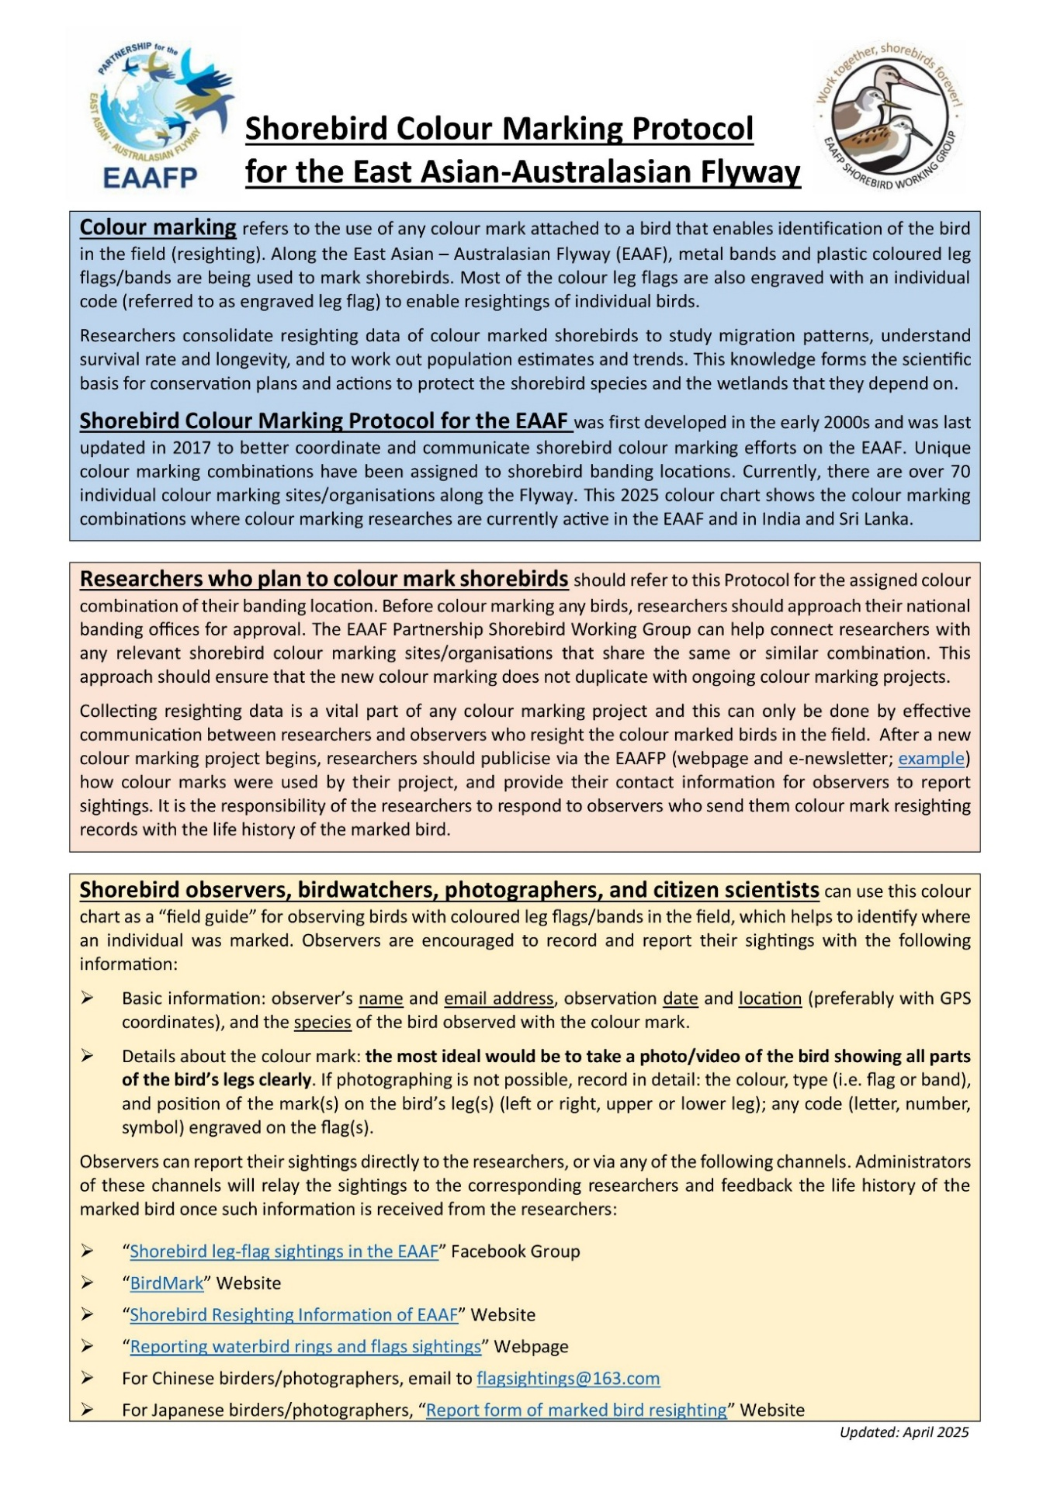
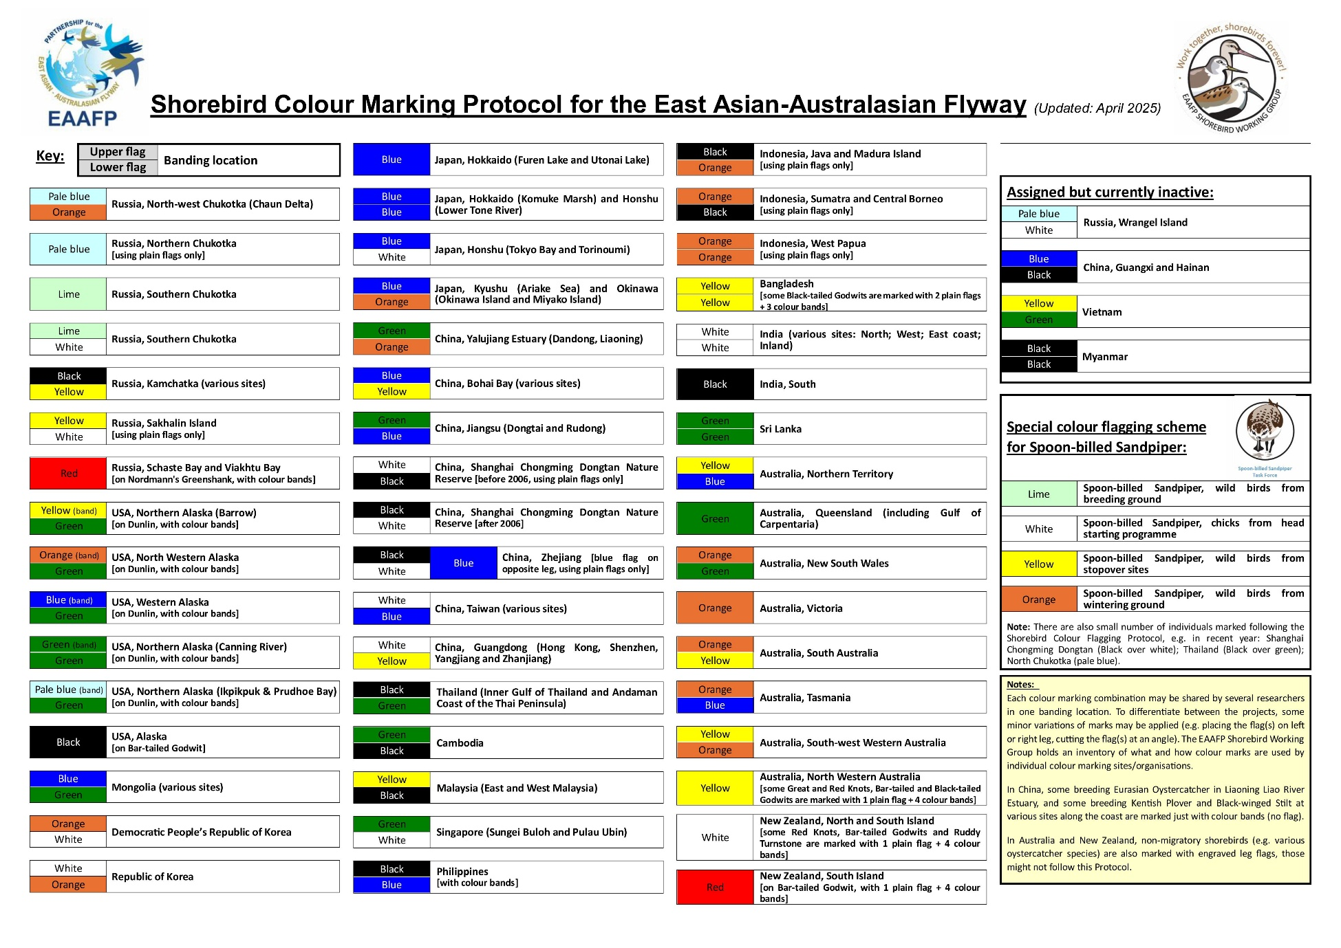
Appendix II
Terms of Reference of the EAAFP Colour Marking Task Force

Goal: To enhance flyway research and monitoring activities, build knowledge and promote exchange of information on waterbirds and their habitats through the coordination of colour marking of migratory waterbirds. [Partnership Document para 5; Strategic Plan Objective 3 To enhance Flyway research and monitoring activities]

2. Role
The role of the EAAFP Colour Marking Task Force is to:
- Support the Secretariat Science Unit in coordinating the colour marking of all migratory waterbirds across the EAAF, including through the taxa-specific Working Groups and Task Forces.
- Collate information on existing and historic colour marking programmes for migratory waterbirds in the EAAF and, where relevant, adjacent flyways.
- Act as a point of liaison with other relevant bird banding/ringing agencies regarding coordination of colour marking.
- To promote the dissemination of information on colour marking activities, including through the EAAFP website.
- With the support of the Science Unit, to report to MOP13 on:
A) the current administration of colour-marking of migratory waterbirds within the EAAF and
B) make recommendations for future coordination of current colour-marking and the development of protocols for all migratory waterbird taxa for considering any new marking schemes.

3. Term
The EAAFP Colour Marking Task Force will operate until the end of 2027 [MOP13] at which time its function and Terms of Reference will be reviewed in light of the report to be prepared by the Science Unit and submitted to the MOP.

4. Membership
Membership of the EAAFP Colour Marking Task Force is open to:
1. National bird banding/ringing offices of EAAFP Government Partners or other government agencies controlling capture and marking of birds in those Partner countries without a national banding/ringing authority.
2. The designated representative of each EAAFP taxonomic Working Group and Task Force.
3. A member of the Secretariat Science Unit.
4. Other experts as required.

5. Officers

The EAAF Colour Marking Task Force is administered by a Chair and one or more Coordinators. The Chair and Coordinator(s) will be elected by the EAAFP Colour Marking Task Force. The Chair and Coordinator(s) are elected for a two-year term and can be renewed at the discretion of the Task Force members.

6. Meetings
The EAAFP Colour Marking Task Force will aim to hold face-to-face meetings at least once a year. Other face-to-face meetings may be arranged as circumstances allow (e.g., at EAAFP MOPs and Science Meetings). Between meetings, business will be conducted electronically.

7. Implementation Arrangements for the EAAFP Colour Marking Task Force Work Program
The EAAFP Secretariat will provide assistance with communication mechanisms for the Colour Marking Task Force.

8. Expenses
Unless there is prior agreement, EAAF Colour Marking Task Force members and other meeting attendees are responsible for their own travel and associated expenses.

2013. Report of the Seventh Meeting of Partners, 3.6 Brief update from EAAFP Working Groups and other special purpose groups, p. 24
2015. Report of the Eight Meeting of the Partners, 3.2.2.5. PMNT, p. 85
2023. Draft minutes of the 10th Meting of Partners, para. 503

