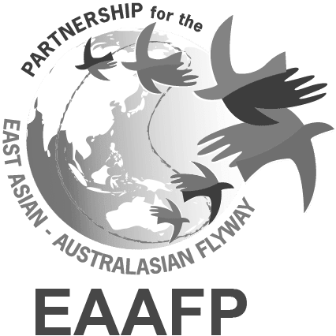

EAAFP Management Committee Meeting

24 February 2023

Date: 24 February, 2023 16:00 – (KST)
Link: https://us02web.zoom.us/j/83458990768?pwd=U05HWG1GOGVoZmlDZndrVkdEb00yUT09

Participants

- Confirmed: All confirmed https://www.eaaflyway.net/management-committee/
- EAAFP Secretariat: Doug Watkins (CE), Hyeseon Do (PO), Vivian Fu (CO), Hyojung Yoo (FO)
- Observers: EAAFP Secretariat (1) - Yunjeong Choi (PA)

Agenda

- Last Management Committee minutes (report on follow-up actions), 8 September 2022 (Last MC Meeting Minutes)

- Follow-up Actions on previous Management Committee meeting
- Ward to consult with WI as to the use of their database to inform the completion of the FNS SISs.
- The Science Unit Workplan as well as the corresponding MOP decision is to be recirculated and revisited
- Secretariat to be approached as to the support/funding with ADB for the Mid-Term Review of the Strategic Plan, Timetable for the Mid-Term Review to be decided and a proposal brought to the next MOP
- Mechanism for co-option and alternatives for FsC and TsC committees to be discussed

- New CE’s Recruitment
- Robb Kaler (Chair), Shufen Yang (Vice Chair), Nick Davidson (TsC Chair), Martin Spray (FsC Chair), and Ivan volunteered to be a part of the new CE recruitment panel

- Other Flyway Issue
- Note to be sent to Partners to advise researchers to exercise caution when accessing seabird colonies.
- Ward to consult with Taej regarding updates regarding this situation and will report back to the MC.

- Update on MOP 11 Preparation Status

  - General update (no. of registration, Reports received, pre-site visit etc)

- Partner reports received: 34 (including WGs/TFs)
- Partners registered for MOP11: 33 (DPRK, Mongolia, CAFF, Ramar, CBD, Rio Tino)
- Observer countries: Lao PDR (TBC), Brunei (TBC), India (Confirmed)
- Registration forms received (mainly overseas): 163

  - Revisit Budget status for MoP11

2.3 Recruitments for MoP Committees

- New Management Committee Chair needs to be identified.
- Candidates for: New Chair, Management Committee members
- Technical Sub-Committee (existing?)
- Finance Sub-Committee Chair and members
- ADB MoU (update) for review by Committees with a view to signing at MoP?
- World Migratory Bird Day MoU - with a view to signing at MoP?

2.4 Visa issues?

2.5 Appointment of Chair and Vice-Chair for MoP11

- According to Rule 18.12 of the Rule of Procedure, a Chair and one or more Vice-Chairs shall be elected at the start of each MoP from the Partners present at the meeting, on the basis of a proposal put forward by the Meeting Committee. The Meeting Committee shall consider first the candidate(s) put forward by the host country of the meeting for the post of Chair of the meeting. (In the case of MoP10, Guangchun has told us that China would not want to be Chair once again which means that we need to identify another Country Partner who would take on this role.)

2.6 Review of the updated MOP11 Program

2.7 Rules of Procedure

- Rule 6 and 7 concerns the admittance of observers, bodies or agencies to the MoP. The Secretariat is preparing a paper with a list of such observers, bodies or agencies, based on a template from the Ramsar Convention (attached), that have been received by Friday 2 November. However, it can be expected that registration will continue to be received and so this list will have to be updated at the start of the MoP for approval by the Partners;
- Rule 14 states that the Secretariat needs to report on the administrative and financial implications of all substantive agenda items submitted to the MOP. As a result, the Secretariat is now working on this paper using a similar paper from the Ramsar Convention (attached) as a template.

- Update on the activities of the EAAFP Secretariat (and the Foundation)
4. Operation of Science Unit

- Updates from FsC and TsC

- New CE’s Recruitment

- AOB

